GANPAT UNIVERSITY

U.V.PATEL COLLEGE OF ENGINEERING & TECHNOLOGY Department of Computer Science and Engineering B.Tech 1ST Semester 1 Subject – ESFP

First Name: Kunal Jain Enrollment Number: T14012111011 Stream : CSE (MA)

Assignment Date:27/08/2014

Q1.Write a program to print ASCII values of all backslash characters and white space on screen in following format :

The ASCII value of ‘\t’ is : 9

ANS

#include<conio.h>

#include<stdio.h>

#include<math.h>

void main()

{

char a,b,d,e,f,g,h,i,j,k,l,m;

int c;

a='\a';

b='\b';

d='\f';

e='\n';

f='\r';

g='\t';

h='\v';

i='\'';

j='\"';

k='\?';

l='\\';

m='\0';

clrscr();

c=a;

printf("\n Ascii value of \'\\a\' =%d",c);

c=b;

printf("\n Ascii value of \'\\b\' =%d",c);

c=d;

printf("\n Ascii value of \'\\f\' =%d",c);

c=e;

printf("\n Ascii value of \'\\n\' =%d",c);

c=f;

printf("\n Ascii value of \'\\r\' =%d",c);

c=g;

printf("\n Ascii value of \'\\t\' =%d",c);

c=h;

printf("\n Ascii value of \'\\v\' =%d",c);

c=i;

printf("\n Ascii value of \'\\\'\' =%d",c);

c=j;

printf("\n Ascii value of \'\\\"\' =%d",c);

c=k;

printf("\n Ascii value of \'\\?\' =%d",c);

c=l;

printf("\n Ascii value of \'\\\\\' =%d",c);

c=m;

printf("\n Ascii value of \'\\0\' =%d",c);

getch();

}

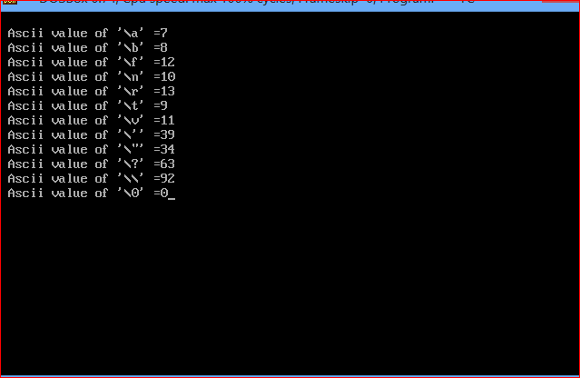

Q2.Explain different data types available in C.

Data Types in C Language

A C program usually contains different types of data types (integer, float, character

etc.) and need to store the values being used in the program. C language is rich of data types.

A C programmer has to employ proper data type as per his requirements.

C has different data types for different types of data and can be broadly classified as:

1. Primary Data Types

2. Secondary Data Types

Primary Data type contains:

* Character

Character type variable can hold a single character and are declared by using the keyword char.

Syntax:

char <variable name>;

* Integer

Integers are whole numbers with a range of values, range of values are machine dependent.

Generally an integer occupies 2 bytes memory space and its value range limited to -32768 to +32767

Syntax:

int <variable name>;

* Float

The float data type is used to store fractional numbers (real numbers) with 6 digits of precision.

Syntax:

float <variable name>;

* void

The void type has no values therefore we cannot declare it as variable as we did in case of integer and float. The void data type is usually used with function to specify its type.

Secondary Data types:

* Array
* pointer
* structure
* enum

Q3.Explain about C Tokens in brief.

ANS

In a C source program, the basic element recognized by the compiler is the "token." A token is source-program text that the compiler does not break down into component elements.

There are 6 types of tokens in 'C'.

They are:

1) Keywords

A variable is meaningful name of data storage location in computer memory.When using a variable you refer to memory address of computer.

2) Identifiers

The term identifier is used for Variable names.

3) Constants

Constants are expressions with a fixed value.

4) Strings

Sequence of characters.

5) Special symbols

Symbols other than the alphabets and digits and white-spaces

6) Operators

A symbol that represent a specific mathematical or non mathematical action.

Q4.Explain about backslash characters in C.

ANS

C supports some special backslash character constants that are used in output functions.

